

Travlr Getaways

CS 465 Project Software Design Document
Version 3.0

Table of Contents

CS 465 Project Software Design Document 1
Table of Contents 2
Document Revision History 2
Instructions 2
Executive Summary 3
Design Constraints 3
System Architecture View 3
Component Diagram 3
Sequence Diagram 4
Class Diagram 4
API Endpoints 4
The User Interface 4

Document Revision History

Version | Date | Author | Comments
1.0 | 03/25/26 | Jas King | Added executive summary description, documented key design constraints and their development implications, and described overall system architecture using the provided component diagram.
2.0 | 04/05/26 | Jas King | Added sequence diagram and class diagram with written explanations, and documented REST API endpoints in the SDD.
3.0 | 04/16/26 | Jas King | Added User Interface section with detailed summary comparing Angular SPA and Express MVC structures, and described SPA functionality and testing process.

Executive Summary

The Travlr Getaways web application is built using a contemporary full‑stack architecture that clearly delineates responsibilities across well-defined layers. This approach promotes scalability, maintainability, and long-term adaptability as business requirements evolve. The application leverages the MEAN stack, consisting of MongoDB for data storage, Express.js and Node.js for server-side processing, and Angular for client-side development.

The system consists of two primary user-facing components: a customer-facing website and an administrator single-page application (SPA). The customer-facing website allows users to browse available travel options, view trip details, and interact with general site content. This interface emphasizes responsiveness, performance, and intuitive design to ensure a positive end-user experience.

The administrator SPA is a secured Angular-based interface that enables authorized users to create, edit, and manage travel listings. Implementing the admin panel as a SPA enhances usability by providing dynamic content updates, improved responsiveness, and reduced server overhead compared to traditional multi-page applications. All administrative actions are performed through RESTful API calls rather than direct database access.

At the core of the system is a backend application built with Node.js and Express.js. This layer contains the business logic, processes client requests, enforces access control, and manages interactions with the MongoDB database. Together, these components form a modular and adaptable system that meets Travlr Getaways’ current requirements while supporting future enhancements.

Design Constraints

The development of the Travlr Getaways web application is influenced by several design constraints that guide its implementation. One major constraint is the required use of the MEAN stack, which dictates the technologies used across the application. While this limits alternative frameworks, it also provides consistency by utilizing JavaScript throughout the stack, improving development efficiency and reducing context switching.

Scalability is another critical constraint. The system must support increasing user traffic and data volume without requiring extensive architectural changes. This requirement influences decisions such as maintaining a stateless backend, decoupling client applications from server logic, and exposing functionality through RESTful APIs. Although these approaches require additional upfront planning, they enable horizontal scaling as demand grows.

Security introduces further constraints, particularly for the administrator SPA. Administrative functionality must be protected against unauthorized access through authentication, route protection, and request validation. These requirements increase development and testing complexity but are essential for maintaining data integrity and system security.

Finally, the academic nature of the project and its milestone-based delivery limit the early adoption of advanced optimizations. Architectural decisions therefore prioritize clarity, modularity, and correctness over performance tuning, ensuring that the system is understandable, extensible, and aligned with instructional objectives.

System Architecture View

Component Diagram

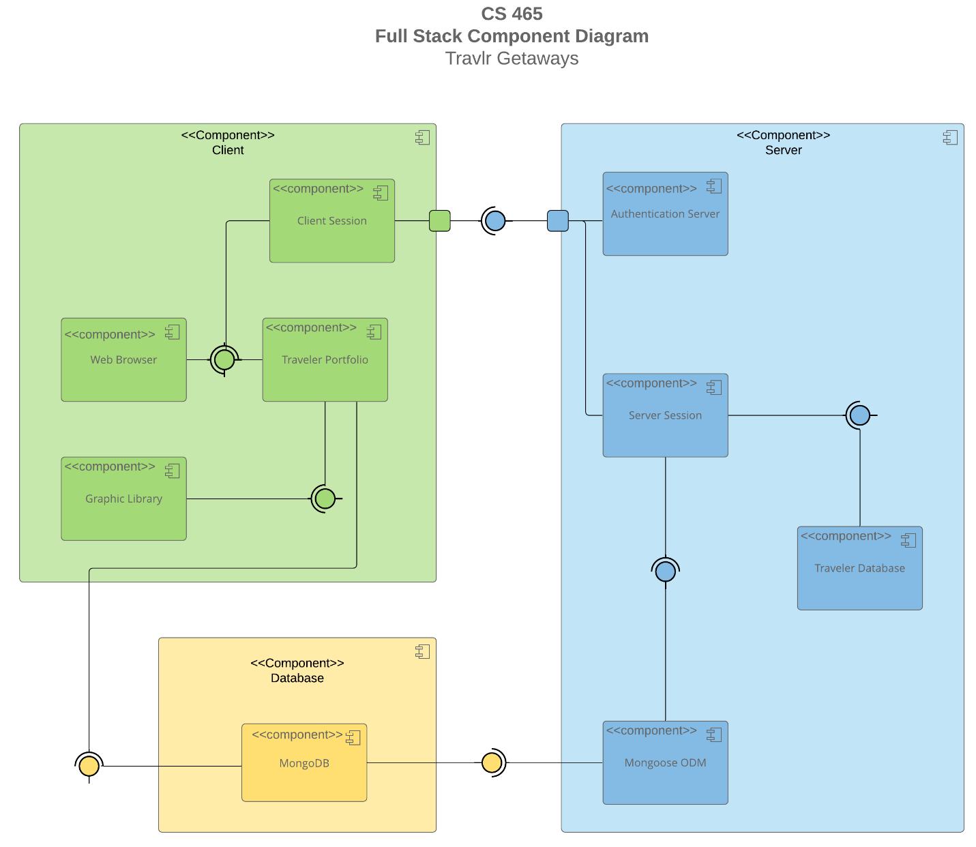

A text version of the component diagram is available: CS 465 Full Stack Component Diagram Text Version.

The Travlr Getaways application follows a layered architecture, as illustrated in the component diagram. The diagram depicts two client components, the customer-facing interface and the administrator SPA, communicating with a centralized application server through HTTP-based RESTful APIs.

The Node.js and Express.js application server functions as the orchestration layer, handling incoming requests, enforcing business rules, managing authentication and authorization, and mediating access to persistent data. The MongoDB database serves as the system’s data storage layer, storing trip information and administrative records.

All data access is restricted to the application server, ensuring consistent validation and controlled interaction with the database. This clear separation of concerns enhances maintainability, supports scalability, and enables future expansion without significant architectural restructuring.

Sequence Diagram

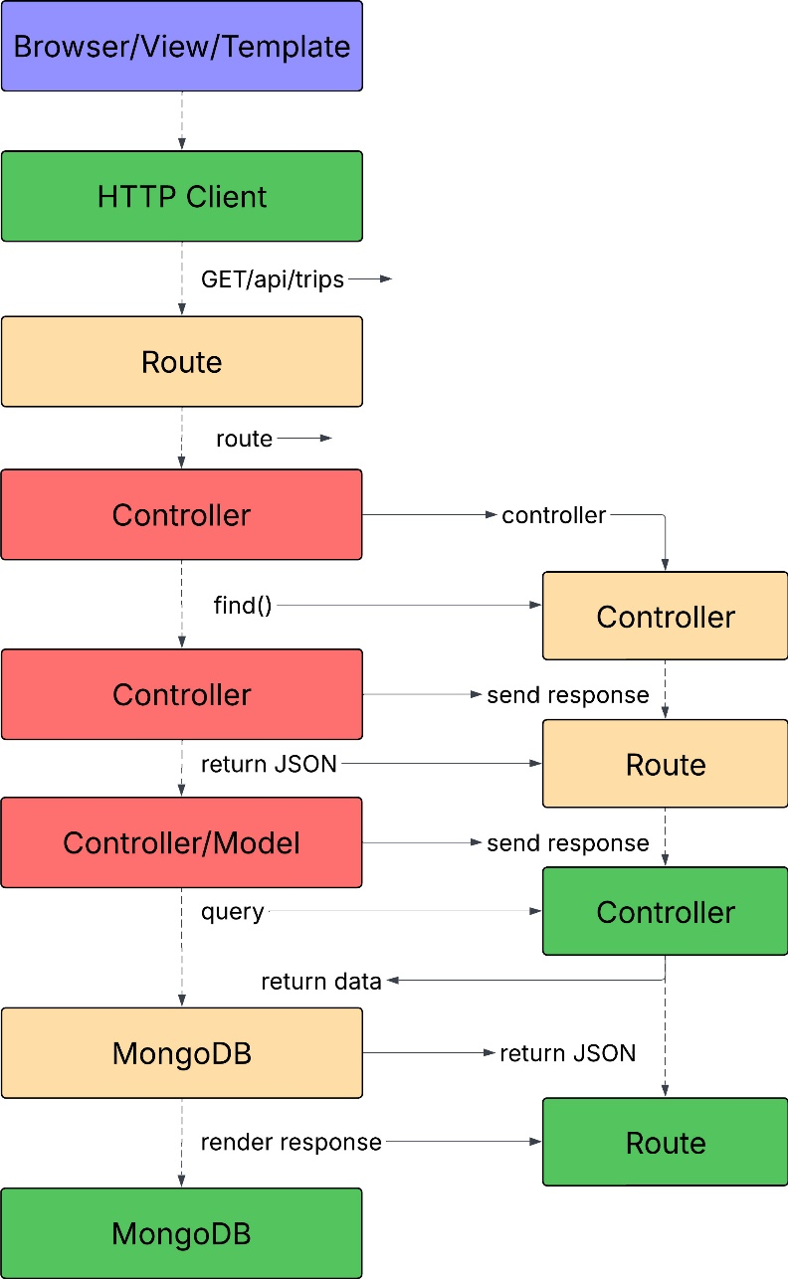

The sequence diagram below follows the standard flow for a web application request. When a user interacts with the browser (client), the browser sends an HTTP request to the Express server. The server’s route receives the request and passes it to the appropriate controller. The controller interacts with the Mongoose model, which queries the MongoDB database. The database returns the result to the model, which passes it back to the controller, then to the route, and finally to the browser for rendering. This sequence ensures clear separation between client, server logic, and data access, and matches the layout of the provided example.

Class Diagram

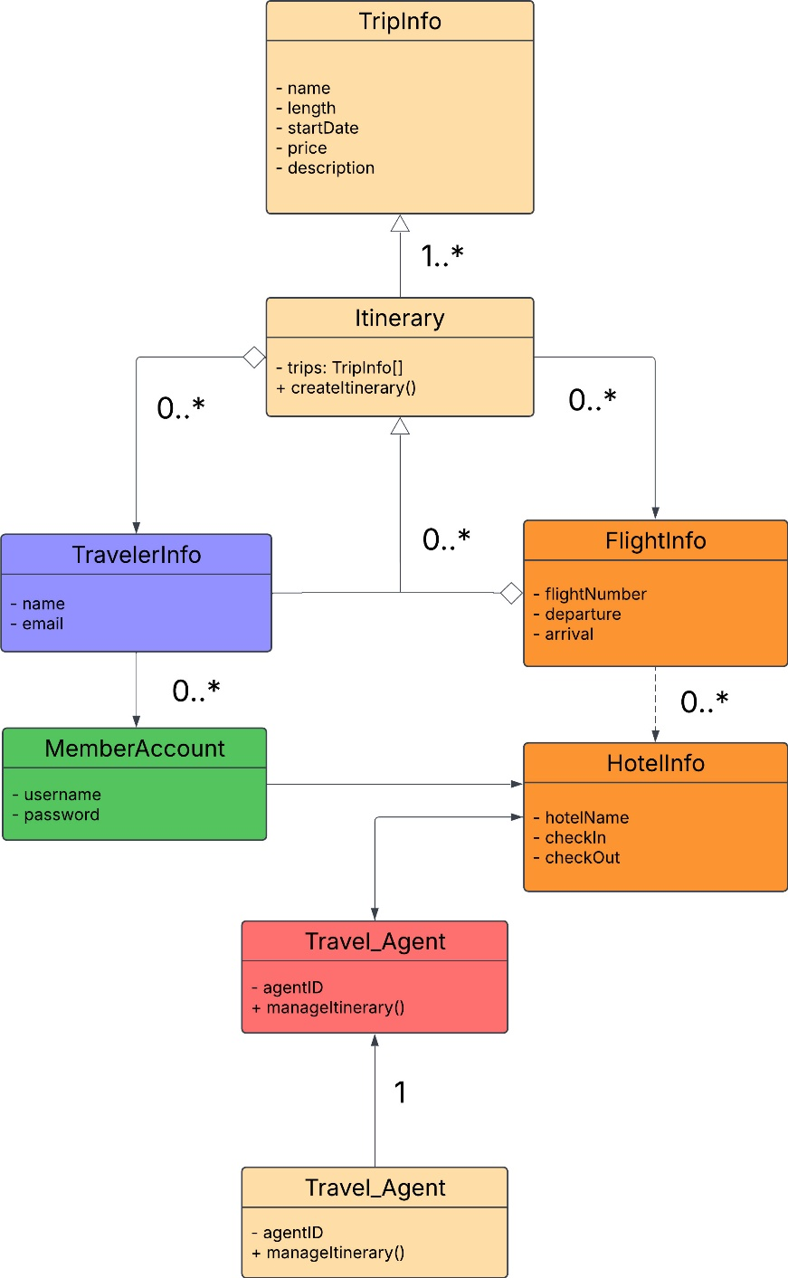

The class diagram represents the main JavaScript classes and their relationships in the Travlr Getaways application. TripInfo contains details about each travel offering, such as duration, price, and schedule. Itinerary aggregates trip information and may reference related classes like FlightInfo, HotelInfo, and CruiseInfo. TravellerInfo and MemberAccount represent user data, while Travel_Agent manages itineraries. This structure supports modular design and reflects how different aspects of travel planning interact within the application.

API Endpoints

The REST API exposes endpoints that allow client applications to retrieve trip data. The /api/trips endpoint returns a collection of all trips stored in MongoDB, while /api/trips/:tripId returns a specific trip based on a unique identifier. These endpoints enable separation between the front-end application and the data layer, allowing the API to be reused by different clients.

Method | Purpose | URL | Notes
GET | Retrieve all trips | /api/trips | Returns all active trips as a JSON array
GET | Retrieve single trip | /api/things/:tripId | Returns a single trip instance, identified by the trip ID

The User Interface

Angular Project Structure vs. Express Project Structure:
The Angular Single Page Application (SPA) is built around reusable components, services, and models. Components are responsible for rendering the user interface and handling user interactions, while services take care of API communication and business logic. Models outline the data structure used throughout the app. Angular's routing allows for dynamic navigation between views without needing to reload the entire page.

On the other hand, the Express project adheres to the MVC (Model-View-Controller) pattern, where routes guide requests to controllers that interact with Mongoose models and render views using Handlebars templates. The Express application is server-rendered, meaning each page request generates a new HTML response from the server.

SPA Functionality Compared to Simple Web Application:
The SPA offers enhanced functionality by allowing dynamic updates to the user interface, real-time form validation, and smooth navigation. Unlike traditional multi-page applications, the SPA only updates the necessary parts of the page, leading to quicker interactions and a more fluid user experience. Administrative tasks like adding, editing, and deleting trips are executed through RESTful API calls, providing immediate feedback and lowering server load.

Testing Process:
To ensure the SPA integrates well with the API, I utilized Postman to check the REST endpoints (GET, POST, PUT, DELETE) and verified that the Angular admin interface could fetch and modify data in the MongoDB database. Angular forms were employed to submit new trips and edit existing ones, with results validated by reviewing the updated trip list and individual trip details. I took screenshots to document successful CRUD operations and showcase the integration between the SPA and the backend API.

